National University of Computer and Emerging Sciences



Object Oriented Programming

Assignment 2.0

|  |  |
| --- | --- |
| Name | Muhammad Zain |
| Roll No. | 19F-0228 |
| Course INSTRUCTOR | Dr Danish Shehzad |
| Semester | Spring 2020 |

Task 1

# Source code;

#include <iostream>

using namespace std;

void diagram()

{

cout << " ``````````````````Tower of Hanoi`````````````````` " << endl;

cout << "| | | |" << endl;

cout << "| | | |" << endl;

cout << "| | | |" << endl;

cout << "| | | |" << endl;

cout << "| | | |" << endl;

cout << "| | | |" << endl;

cout << "|Disk 1 <<<|>>> | |" << endl;

cout << "|Disk 2 <<<<<<|>>>>>> | |" << endl;

cout << "|Disk 3 <<<<<<<<|>>>>>>>>> | |" << endl;

cout << "| --------|------- --------|------- --------|------- " << endl<<endl;

cout << "| Tower 1 Tower2 Tower 3" << endl<<endl<<endl;

}

void Function(int size, char First, char Third, char second)

{

if (size == 1)

{

cout << "First Disk will move from Place " << First << " to " << Third << endl;

return;

}

Function(size - 1, First, second, Third);

cout << "First Disk will move from Place " << First << " to " << Third << endl;

Function(size - 1, second, Third, First); //RECURSIVE FUNCTION

}

int main()

{

diagram();

cout << "lets have a look one the rules first" << endl<<endl;

cout << " 1: Object of the game is to move all the disks From tower1 to Tower 3."<<endl;

cout << " 2: But you cannot place a larger disk onto a smaller disk. " << endl<<endl;

int size = 3;//3 DISK //MINIMUM MOVES 7

Function(size, '1', '3', '2');//DUMMY VARIABLE 1//DUMMY VARIABLE 2//DUMMY VARIABLE 3

system("pause>0");

}

# Snip;

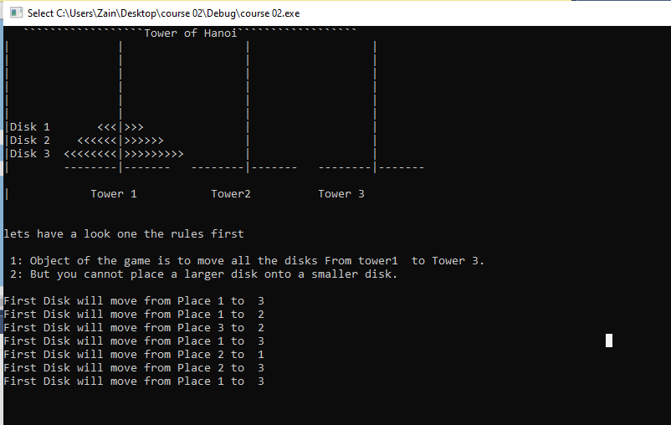

Task 2

# Source Code;

#include <iostream>

using namespace std;

int Maximum(int A[], int size)

{

if (size == 1)

return A[5];

else

{

return (A[size - 1], Maximum(A, size - 1));

}

}

int Minimum(int A[], int size)

{

if (size == 1)

return A[0];

return (A[size - 1], Minimum(A, size - 1));

}

int main()

{

int array[6];

cout << "Enter 6 elements of array" << endl;

for (int i = 0; i < 6; i++)

{

cin >> array[i];

}

int Half = sizeof(array) / sizeof(array[0]);//ta k adhi amount ke check ho jo pori array sort krday warna dobaar ho k phir wasi bn jani thi

cout <<"The Minimum value in the array is = "<<Minimum(array, Half) << endl<<endl;

cout <<"The Maximum value in the array is = " <<Maximum(array, Half)<<endl<<endl;

system("pause>0");

}

# Snip;

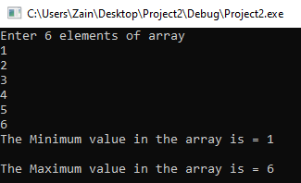

Task 3;

# Source Code;

#include <iostream>

#include <string>

using namespace std;

int main()

{

cout << "Input String" << endl;

string names[5];

for (int i = 0; i < 3; i++)

{

cin>> names[i];

}

//Show array

cout << "REAL STRING = ";

for (int i = 0; i < 3; i++)

{

cout << names[i] << " ";

}

//Sort array

string temp;

for (int i = 0; i < 3; i++)

{

for (int j = i + 1; j < 3; j++)

{

if (names[j] < names[i])

{

temp = names[j];

names[j] = names[i];

names[i] = temp;

}

}

}

cout <<endl<< "Reversed String = ";

for (int i = 0; i < 5; i++)

{

cout << names[i] << " ";

}

system("pause> 0");

}

# Snip;

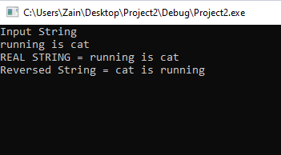

Task 5;

# Source Code;

#include<iostream>

#include<string>

using namespace std;

struct student {

string Name;

double Cnic;

string Gender;

double Cgpa;

};

struct section {

student*array;

string SectionName;

string ClassTeacher;

};

int main()

{int index; section E;int n;

E.array = new student[40];

int choice; int numberOfSections;

cout << "Press 1 to Change Name" << endl;

cout << "Press 2 to Change Cnic " << endl;

cout << "Press 3 to whole entries of students" << endl;

cout << "Press 4 to exit" << endl;

cin >> choice;

if (choice == 1)

{

cout << "iNPUT THE NUMBER OF STUDENT" << endl;

cin >> index;

cin >> E.array[index].Name;

}

if (choice == 2)

{

cout << "iNPUT THE NUMBER OF a STUDENT" << endl;

cin >> index;

cin >> E.array[index].Cnic;

}

if (choice == 3)

{cout << "Input the numbers of sections you want to enter" << endl;

cin >> numberOfSections;

cout << "enter number of students of whom data you want to enter" << endl;

cin >> n;

cout << endl << "Enter your Name CNic Cgpa And Gender Respectively" << endl;

for (int i = 0; i < numberOfSections; i++)

{

for (int numberofStudents = 0; numberofStudents < n; numberofStudents++)

{

if (numberofStudents >= 40)

{

++numberOfSections;

}

else if (numberofStudents < 40)

{

cin >> E.array[numberofStudents].Name;

cin >> E.array[numberofStudents].Cnic;

cin >> E.array[numberofStudents].Cgpa;

cin >> E.array[numberofStudents].Gender;

}

}

}

for (int i = 0; i < numberOfSections; i++)

{

for (int numberofStudents = 0; numberofStudents < n; numberofStudents++)

{

cout << E.array[numberofStudents].Name;

cout << E.array[numberofStudents].Cnic;

cout << E.array[numberofStudents].Cgpa;

cout << E.array[numberofStudents].Gender;

}

}

}

if (choice == 4)

{

exit;

}

system("pause>0");

}

# Snip;

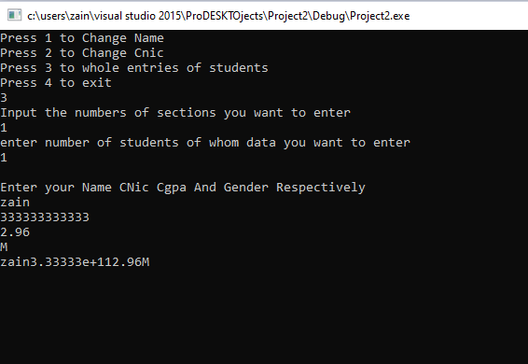

Incomplete due to Mid Term. I shall complete remaining one and half TASK immediately after Mids. Kindly accept second file as well which I will upload along with this one.

Thankyou 😊